**Module INM378 — Digital Signal Processing and Audio Programming**

**Report**

**Task 3a – i):**

***FIR Filter***

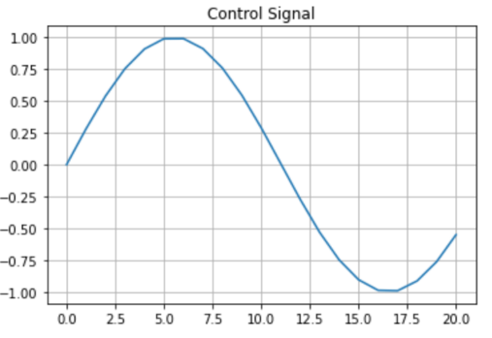

WE programmed a controllable FIR filter that changes its characteristics over time in response to a control signal. Firstly, we define a plotting function in which we compute the frequency response of a digital filter. We define the convolution function and then read the input file. We generate two filters a low pass filter and a high pass filter We generate a control signal with 2 Hz and an arbitrary sampling frequency for control signal at 44100/1000.

We create an interpolated filter and then check the frequency response to low pass, high pass and interpolated as seen below. The last step is to perform the filtering with interpolated filter through the confusion function.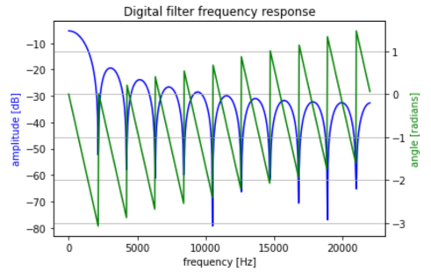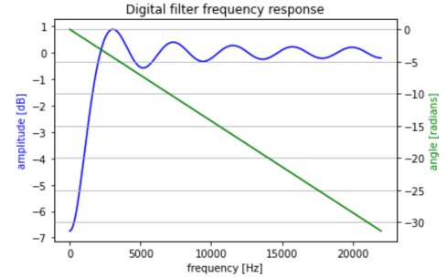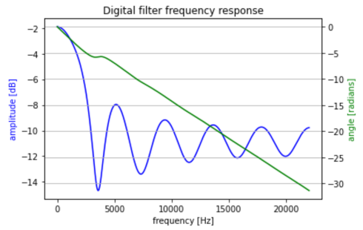

***Digit Recognition***

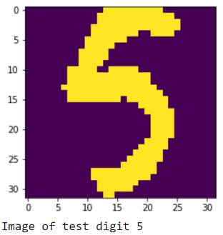

We start off by defining a function to compare the test and training data. In this function we calculate the sum of element wise between the two.

We test our function by running it on an index equal to 2, but before we do, we print the image to see the digit as seen on the right. The result is good as we get a predicted label as 5. We then run the function on all the test data and get an accuracy of 90.14%.

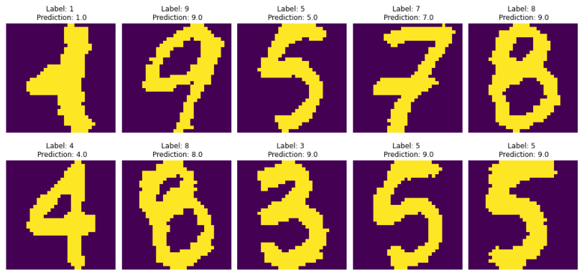

The next step is to create a function to calculate the correlation using correlate2d. We then run the function on a subset of the data of only 50 samples and only get an accuracy of 50.80%, on the right are the first 10 samples and their predictions.

The next steps were to manipulate the images and rerun our first function to check the correlation between the test and training sets. Below are the output of image at index 0 with the manipulations from left to right (inverted, rotated and noise).

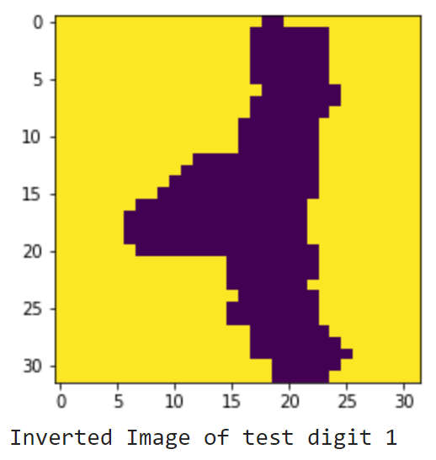 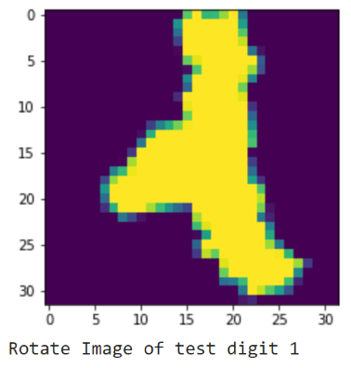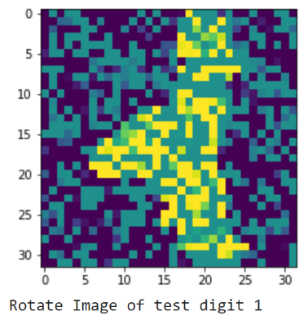

After inverting the images and running the comparison function, we achieve an accuracy level of 90.88% which is slightly more accurate than the original comparison; this could be due to concise edges of the digits after inverting.

After rotating the images and running the comparison function, we achieve an accuracy level of 90.14%, the loss in accuracy can be due to the distortion of the image.

After adding gaussian noise to the images and running the comparison, we achieve an accuracy level of 90.24%, the loss in accuracy can be due to the introduction of noise.

***Time Series Prediction with Financial Data***

We first look at long term trend by running a linear regression model on the original “real_price” and the log of “real_price” as seen below.

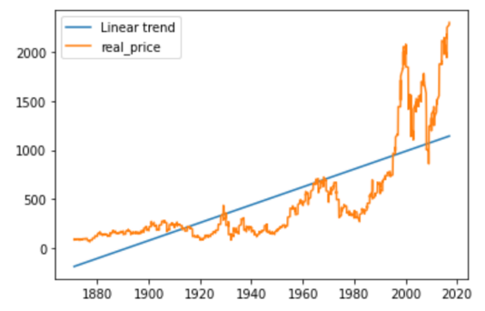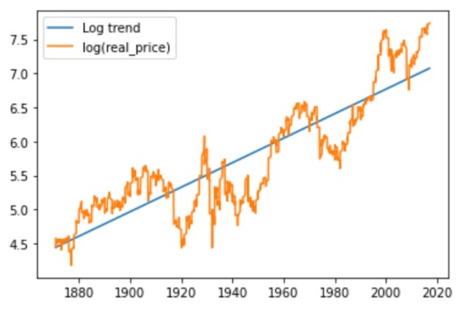

From the original data we can see that the linear trend is a positive upward trend. Looking at the log trend we can see the trend is steeper taking into consideration the higher peaks of price during the latter periods.

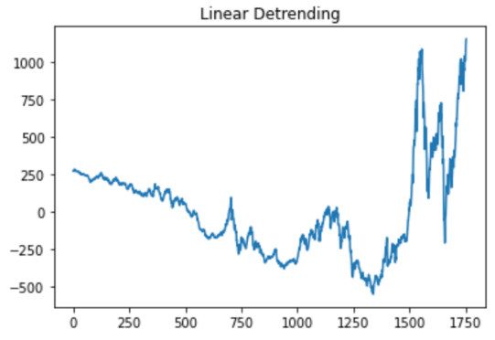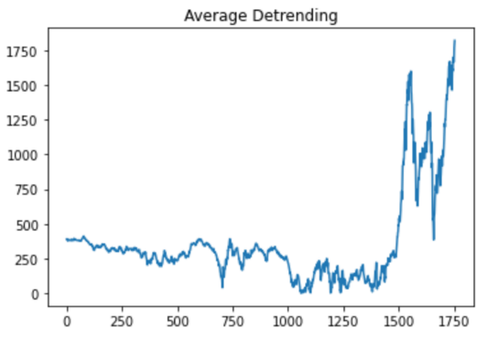

The next steps we take is to detrend the data, above you can see the linear detrending on the left and the average detrending on the right. As we can see out of the two the average detrending looks a better representation of the original data.

The next step is to calculate the FFT of the signal of interest and estimate the periodicities. The first step is to refine the analysis to a daily level. We then create a harmonic model, prediction spectrum and periodic prediction, the results are seen below.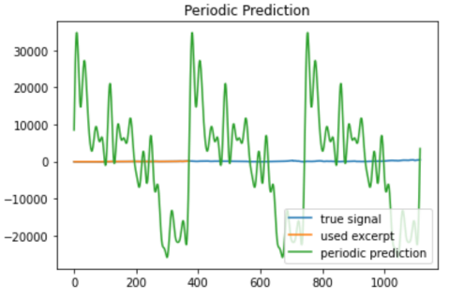

We then rerun the analysis after redefining the analysis to a 5-year period, the results are seen below.